EX NO: 2 | Configure VLANs and inter-VLAN routing in Packet Tracer
DATE:21/07/26

Objectives:
- To create and configure Virtual Local Area Networks (VLANs) for logical network segmentation and traffic isolation.
- To configure Inter-VLAN Routing to enable communication between devices belonging to different VLANs.

Software/Apparatus required:
  - Cisco Packet Tracer
  - End Devices (PCs)
  - Switches
  - Copper Straight-through Cable / Automatic Cable Selector
  - Routers

Procedure
Objective 1: VLAN Configuration
    - Open Cisco Packet Tracer.
    - Place two switches and six PCs in the workspace.
    - Connect the PCs to the switches using straight-through cables.
    - Connect the two switches using a crossover cable.
    - Create VLAN 10 and VLAN 20 on both switches.
    - Assign the ports connected to PC0, PC1, and PC2 to VLAN 10.
    - Assign the ports connected to PC3, PC4, and PC5 to VLAN 20.
    - Configure the link between the switches as a trunk link.
    - Configure the PCs with the required network settings.
    - Verify communication between devices belonging to the same VLAN.
    - Verify that communication between devices in different VLANs is not possible.
    - Save the configuration and observe the results.

Objective 2: Inter-VLAN configuration
- Open Cisco Packet Tracer.
- Place one router, three switches, and six PCs in the workspace.
- Connect the PCs to their respective switches using straight-through cables.
- Connect the access switches to the central switch.
- Connect the router to the central switch.
- Create VLAN 10 and VLAN 20 on the switches.
- Assign the ports connected to PC0, PC1, and PC2 to VLAN 10.
- Assign the ports connected to PC3, PC4, and PC5 to VLAN 20.
- Configure the links between the switches as trunk links.
- Configure the router interfaces to route traffic between VLAN 10 and VLAN 20.
- Configure the required network settings on all PCs.
- Verify communication between devices within the same VLAN.
- Verify communication between devices belonging to different VLANs through the router.
- Save the configuration and observe the results. 15.

Networking diagram:
Objective 1: VLAN Configuration

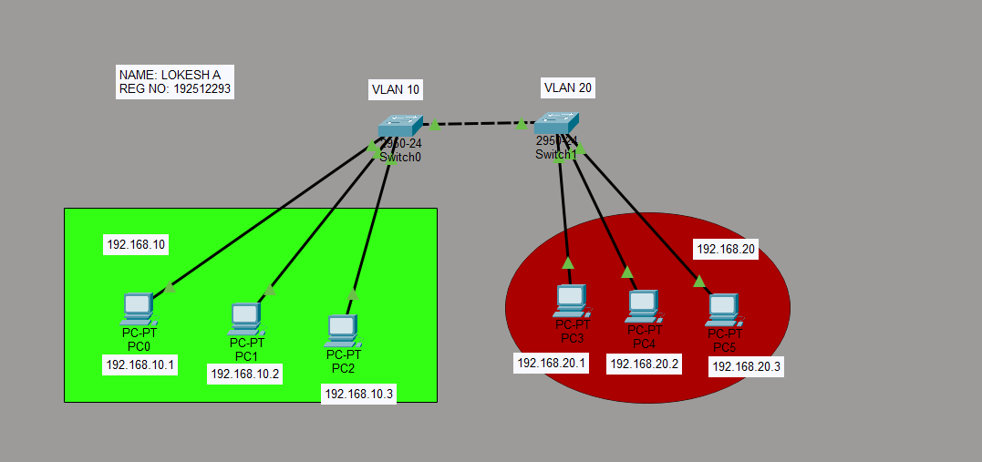

Objective 2: Inter-VLAN Configuration

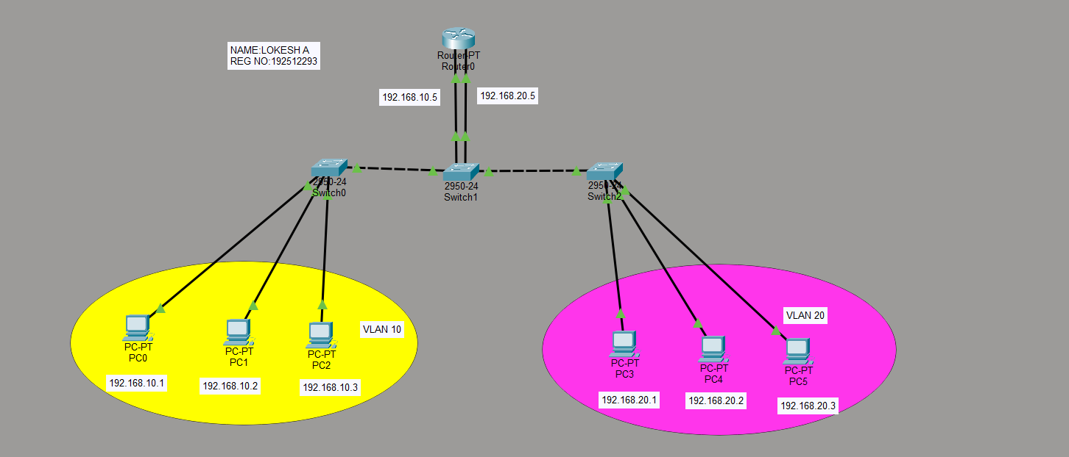

Output:
Objective 1: VLAN Configuration

SI.  No | Source IP | Destination IP | Data sent (bytes) | Data received (bytes)
1. | 192.168.10.1 | 192.168.10.2 | 4 | 4
2. | 192.168.10.2 | 192.168.10.3 | 4 | 4
3. | 192.168.10.3 | 192.168.10.4 | 4 | 4

Objective 2: Inter-VLAN Configuration

SI.  No | Source IP | Destination IP | Data sent (bytes) | Data received (bytes)
1. | 192.168.10.1 | 192.168.20.1 | 4 | 4
2. | 192.168.10.2 | 192.168.20.2 | 4 | 4
3. | 192.168.10.3 | 192.168.20.3 | 4 | 4

Result:

Objective 1: VLAN Configuration
The VLANs were successfully configured, and communication was established only between devices within the same VLAN while communication between different VLANs was restricted.
Objective 2: Inter-VLAN Configuration
- Inter-VLAN Routing was successfully configured, enabling communication between devices belonging to different VLANs through the router.

Test Case Question 1

Implement the specified VLAN topology using Cisco Packet Tracer and analyze the communication between devices.

Case 1
  - VLANs: VLAN 10 and VLAN 20
  - Number of PCs: 4 (2 PCs per VLAN)
  - Number of Switches: 1

Case 2
  - VLANs: VLAN 10 and VLAN 20
  - Number of PCs: 6 (3 PCs per VLAN)
  - Number of Switches: 2
  - Inter-switch Connection: Trunk Link

Tasks
- Construct the specified VLAN topology and configure the required VLANs and switch port assignments.
- Configure the network settings of all end devices and verify communication within the same VLAN.
- Analyze the communication behavior between devices belonging to the same VLAN and different VLANs.

Aim (10) | Networking Diagram  (30) | Procedure (10) | Results (20) | Record (10) | Viva (20) | Total (100)

Test Case Question 2
Implement the specified Inter-VLAN Routing topology using Cisco Packet Tracer and analyze communication between different VLANs.

Case 1
  - VLANs: VLAN 10 and VLAN 20
  - Number of PCs: 4 (2 PCs per VLAN)
  - Number of Switches: 2
  - Number of Routers: 1

Case 2
  - VLANs: VLAN 10 and VLAN 20
  - Number of PCs: 6 (3 PCs per VLAN)
  - Number of Switches: 3
  - Number of Routers: 1

Tasks
- Construct the specified Inter-VLAN Routing topology and configure the required VLANs, trunk links, and router interfaces.
- Configure the network settings and default gateways of all end devices and verify communication between VLANs.
- Analyze the effectiveness of Inter-VLAN Routing in enabling communication between different VLANs and compare it with VLAN-only communication.

Aim (10) | Networking Diagram  (30) | Procedure (10) | Results (20) | Record (10) | Viva (20) | Total (100)

